**Lab 1**

Eric Pires

John Lamanuzzi

Richard Harrison

ECE 388

Team 3

Lab Date: September 14, 2016

Due Date: September 21, 2016



**Table of Contents**

Introduction 2

Methods 2

Testing Procedure 3

Results 3

Discussion 4

Conclusion 4

Reflection 5

References 6

Appendix 7

Abstract

For this laboratory assignment, the Elenco SM-200K surface mounting technology practice kit was assembled. Each component provided in the kit was soldered and examined under a microscope. A test plan was devised to confirm the functionality of the device. The results of this test plan were documented and explained.

# Introduction

The Elenco SM-200K kit is a PCB that introduces the fundamental concepts surface mount soldering. Using a Kendal 899 D+ soldering iron, each component was carefully soldered in its given location as described in the instruction manual. After soldering each component, a testing procedure was followed to ensure that the parts were properly soldered and that the circuit board was functional. The SM-200K can be found in Figure 1 of the Appendix.

# Methods

The step-by-step procedures of assembling the device were found in the instruction manual. To begin the process, the Kendal 899 D+ soldering iron was held to the desired pad to provide enough heat for the solder to flow. After a few seconds of direct contact, the solder was melted onto the pad. Then, the surface mount device was placed onto the heated solder. After applying one pin with solder, the component secures in place and more solder was added to these remaining joint(s). This was done for all components listed in Table 1 of the Appendix.

For soldering the two ICs, electrolytic capacitors, LEDs, and diodes, orientation was observed, as labelled in the manual. For the ICs, the orientation was selected and solder was applied to the corner pins. The ICs were then precisely soldered, pin by pin. These chips can be individually seen in Figures 2 and 3.

The wires (battery snap) and buzzer were the final parts to be soldered on, with very large spaces given on the left-hand side of the board. Since these pads for the snap were so large, a more generous amount of solder was used to ensure the wires would not snap off.

# Testing Procedure

Following the assembly of the SM-200K Decision Maker, a simple testing plan was devised to ensure the device was fully functional. The first step was to inspect the soldering of all the components to ensure no pins were loose. This was done by using a microscope to magnify the view of each pin for each component. Once all components were properly soldered, the next step of the testing procedure was to power on the device. Using a 9V battery as the power source, the dimple switch was pressed and the output devices were observed. These included the buzzer and LEDs. According to the instruction manual, the device was to randomly alternate between each LED and stop at one location, all while playing a tone through the buzzer. Achieving this state in the testing process would confirm a successful design. If the design did not succeed, however, then the instruction manual provided a set of instructions based on the current state of the system. These instructions were also accompanied by a continuity check using a multimeter.

# Results

After several testing iterations, the experiment had emulated the expected behavior as documented in the instruction manual. When connecting the 9V battery, one of the six LEDs illuminated and held position until the dimple switch was pressed. This input caused the buzzer to sound and the LEDs to alternate between each other until eventually landing on a new position. Once the new position was illuminated, the buzzer stopped and only repeated whenever the dimple switch was pressed. A picture of the completed SM-200K can be found in Figures 4 and 5.

# Discussion

The experiment provided a fundamental evaluation of surface mount soldering as well as test driven design. Components that were very close together, or had pins that were close as well (the two ICs are good examples of this) required extra care as to not bridge any pins.

The first iteration of tests revealed a major experimental error. During the power on test phase, the SM-200K was responding in an unexpected manner. The LEDs were continuously alternating and the buzzer played indefinitely while connected to the 9V battery. Since this scenario was not covered in the instruction manual, our team was tasked with evaluating an unknown condition. The solution was to revert to the first step of the test plan. This step helped trace the issue in our system, which was the misalignment of both ICs. After finding this issue, the chips were desoldered using a heating gun and desoldering wick. They were then properly oriented and soldered onto the board.

The second testing iteration had also proved to fail. The system was unresponsive during the power on test. Our group hypothesized that our circuit was shorted. To test this, we used a multimeter to perform a continuity test on all traces. The test showed that pin 12 on IC1 was floating. This was then confirmed by careful examination though the microscope. The pin was properly soldered and the power on test was repeated. The working iteration is described in the Results section.

# Conclusion

This lab was designed to be a relatively simple introduction PCB design, focusing on soldering various surface mount devices to a board and ensuring the finished system works. The lab also provided experience in using testing procedures for better understanding on how to work through the design process. As scenarios not described in the manual arose, problem solving became more important than ever, forcing new ideas to be made on how repair the system. Overall, this lab provided the fundamentals of creating an embedded system through working with test driven design.

# Reflection

This experiment had provided the first real soldering task for each of us. The practice resistors helped introduce the basic concepts of soldering without fear of damaging the circuit. Once this was completed, the rest of the work seemed much easier as the experiment proceeded. The most challenging part of the experiment was tracking system errors. The testing procedure helped fix these errors and complete the given assignment. Based on this experiment, it is right to assume that the design process requires patience and frequent testing to accomplish a given task.

# References

SMT Training Course. Wheeling: Elenco Electronics, Inc., 2008. PDF.

Fortier, Paul. (2016). Laboratory #1. Handout.

# Appendix

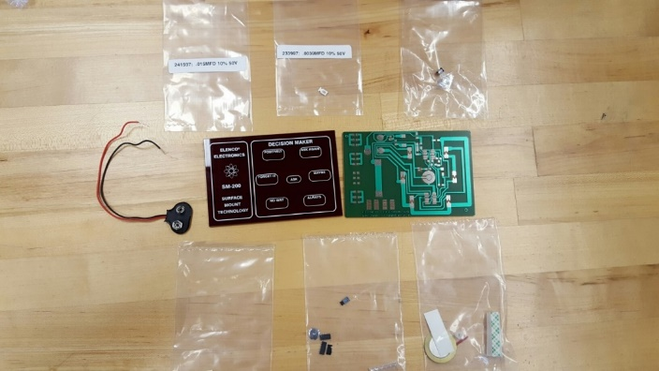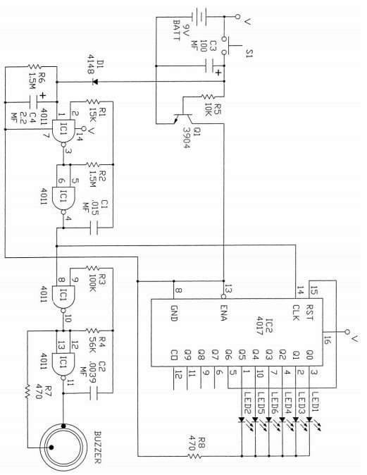

***Figure 1:***  *Elenco SM-200K Kit and Schematic*

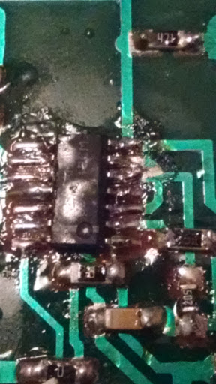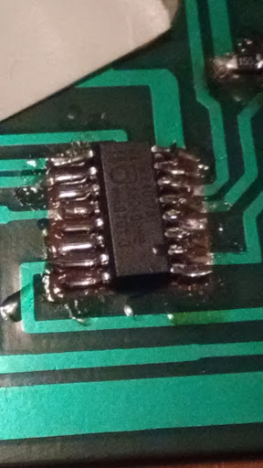

Pin 12 (Source of short)

***Figures 2 and 3:*** *IC 4011 and IC 4017 soldered on PCB.*

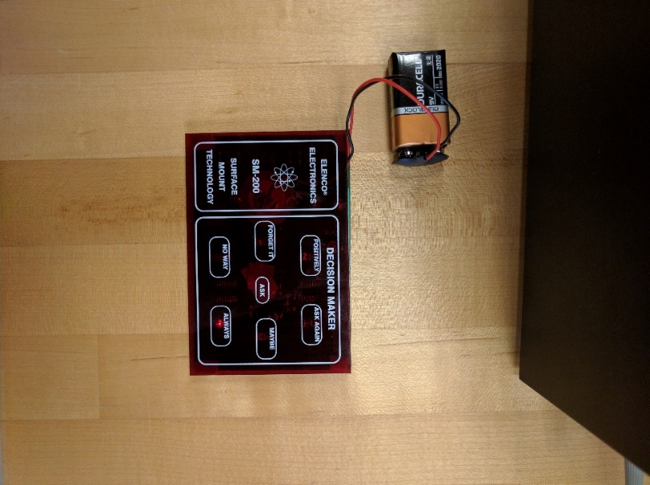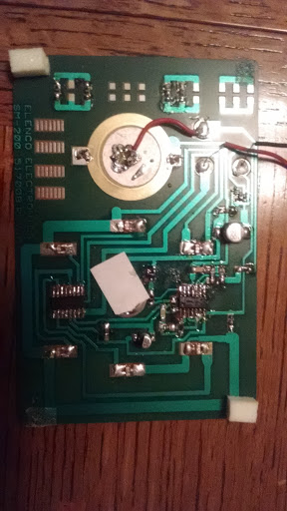

***Figures 4 and 5:*** *Completed Design (Exterior and Interior view)*

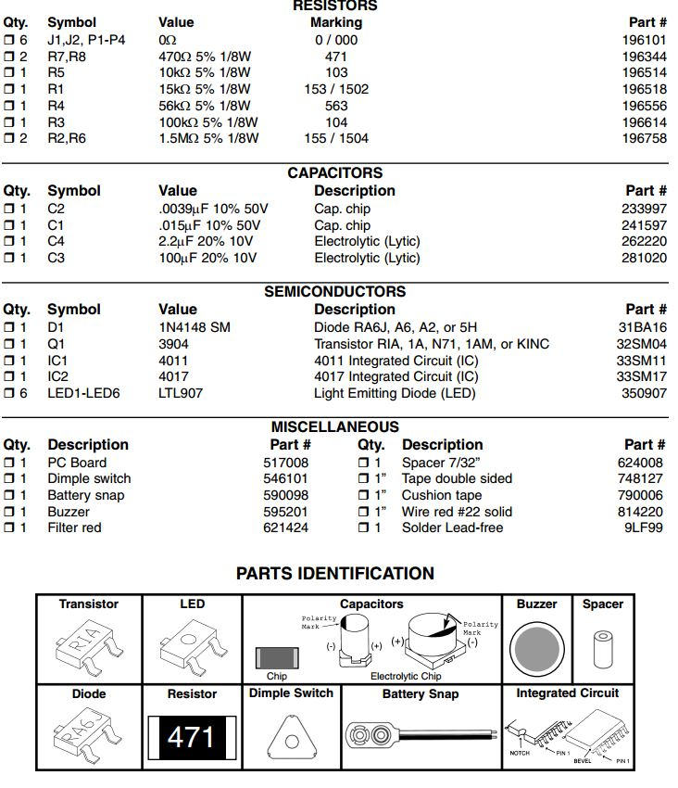

***Table 1:*** *Component List*